Single Compartment Model Questions:

1. Alan uses a sphere as the single compartment, whereas Kira uses a cylinder. Which method is most realistic/useful?
2. How can we say the Volume of the single compartment changes, but the surface area stays constant? With a sphere the only way to change to Volume is to change the radius and that would obviously change the SA.
   1. Kira also uses an area scaling constant while Alan uses the actual area.
3. Most of the conductance values that Kira and Alan use are divided by F (Faraday constant). Why is this done?
   1. Alan has a pump rate that is also divided by F
4. How does Alan calculate his initial concentrations?

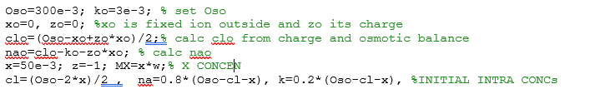i.e. how does he arrive to the equations below?

1. Why does Alan use the cell volume in the voltage equation?



* 1. Why does he update his volume in the following way?